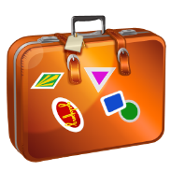
Packing List

Destination:
Duration:
To-do the week before leaving:

Clothing items:

Health & hygiene items:

Paperwork & money:

Miscellaneous items:

To-do the day you leave:
www.OFTHEHEARTH.com

